* Sine Wave – 100Khz f1
  + At 400KHz Sampling Rate
    - t1 = 2.5us

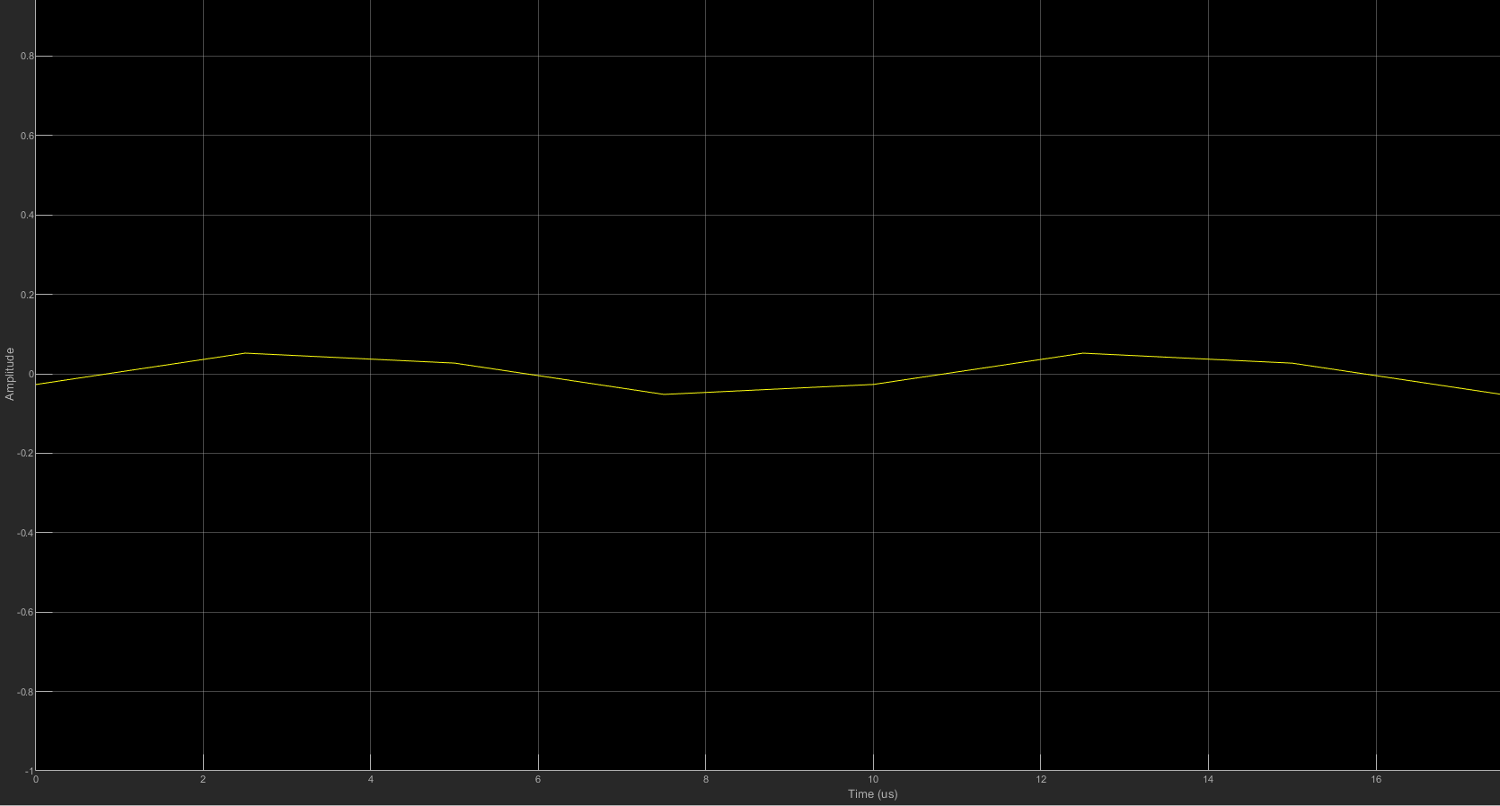

* At 800KHz Sampling rate
  + t1 = 1.25us

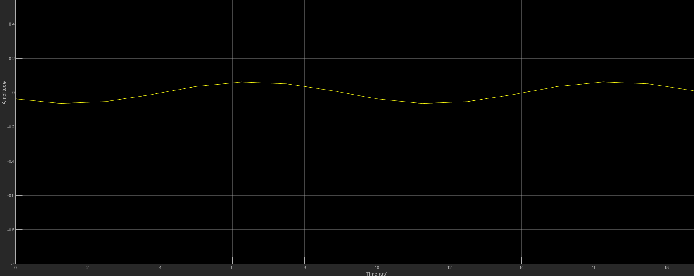

* At 1MHz Sampling Rate
  + t1 = 1 us

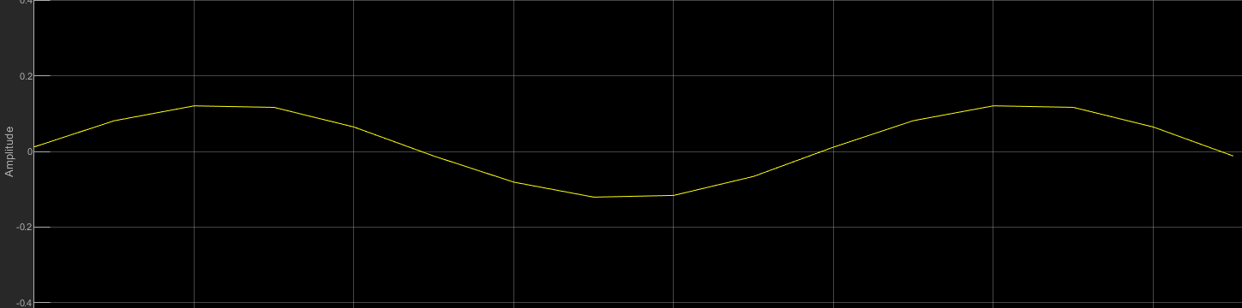

* Frequency Offset Calibration
  + [**https://www.mathworks.com/help/supportpkg/usrpradio/ug/frequency-offset-calibration-with-usrp-tm-hardware.html**](https://www.mathworks.com/help/supportpkg/usrpradio/ug/frequency-offset-calibration-with-usrp-tm-hardware.html)
  + Subtract 2.344 from receiver center frequency